Lesson 04 – Vocabulary

Flow Charts: directly correspond to the flow control statement options

Flow Control Statements: can decide which Python instructions to execute under which conditions

Boolean Data Type: only has 2 values – True or False – CAPITALIZED – named after George Boole

Comparison Operators: compare two values and evaluate down to a single Boolean value

Boolean Operators: And OR Not – used to compare boolean values

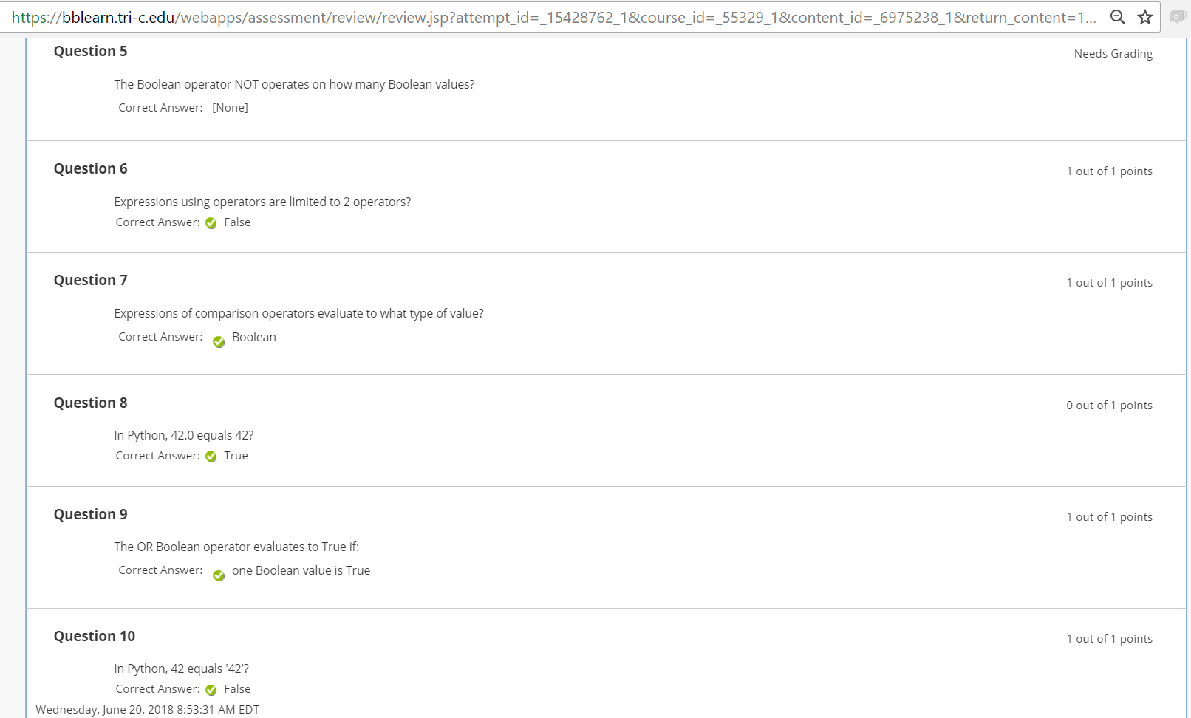

Question 5 – only option was 0 ???